

BANGALORE INSTITUTE OF TECHNOLOGY
(An Autonomous Institution Affiliated to VTU, Belagavi)
K. R. Road, V. V. Puram, Bengaluru – 560004
ASSIGNMENT – 1

“Personal Portfolio Website Development”

Submitted to:
Department of Electronics and Communication
Subject Code: 1BESC204E
Faculty Name: Gahan A V

Submitted by:
Name: R kruthik raj
USN: 1BI25EC108
Roll Number:47
Section: EC-2
Date of Submission: 08-05-202

1. Introduction
A personal portfolio website is a digital platform used to present personal information, educational background, technical skills, achievements, projects, and contact details in an organized and visually attractive manner.
This project focuses on developing a futuristic cyber-themed personal portfolio website using HTML, CSS, and JavaScript. The website is designed with advanced animations, glowing effects, responsive layouts, and interactive particle backgrounds to create a modern user experience.
The website represents the personal profile of R Kruthik Raj, a Bachelor of Engineering student from Bangalore Institute of Technology.

2. Objectives of the Project
The main objectives of this project are:
To create a professional online portfolio.
To present personal information in a creative way.
To improve web development skills.
To design an attractive and responsive website.
To implement animations and interactive effects.
To showcase technical skills and achievements.

3. Technologies Used
Technology | Purpose
HTML | Structure of the website
CSS | Styling and animations
JavaScript | Interactive functionality
Particles.js | Animated particle background
Google Fonts | Futuristic typography

4. Software Requirements
The following software tools are required for this project:
Visual Studio Code / Any Text Editor
Web Browser (Chrome, Edge, Firefox)
Internet Connection (for fonts and particles.js library)

5. Hardware Requirements
Minimum hardware requirements:
Processor: Intel i3 or above
RAM: 4 GB or above
Storage: 1 GB free space
Display: 1366 × 768 resolution or higher

6. Website Features
The portfolio website contains the following features:
6.1 Navigation Bar
Sticky navigation bar
Smooth scrolling effect
Hover glow effects

6.2 Hero Section
Large animated heading
Introduction tagline
Interactive button

6.3 About Section
Personal information
Educational details
Profile photograph

6.4 Skills Section
Technical and non-technical skills
Hover animation effects

6.5 Achievements Section
Workshops
Mini projects
Hackathon participation

6.6 Interests and Hobbies
Drawing
Gaming
Problem solving
Exploring technology
.
6.7 Contact Section
Email
Phone number
LinkedIn profile
GitHub profile

6.8 Particle Background Animation
Interactive animated particles
Hover interaction
Modern cyber appearance

7. screenshots of the website
The following placeholders represent each major section of the website. Screenshots
should be taken by opening the HTML file in Google Chrome and capturing each
section using the browser's built-in screenshot tool or a screen capture application.
The screenshots are attached in the next page

7.1 Hero \ Home section:

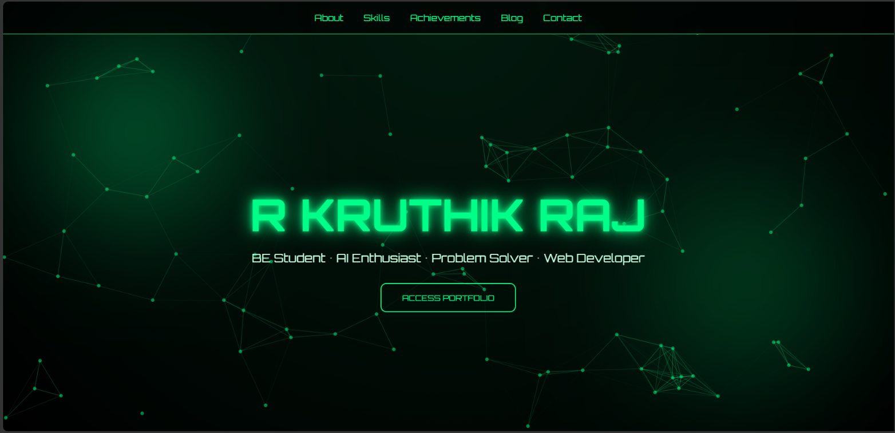

7.2 About me and skills section:

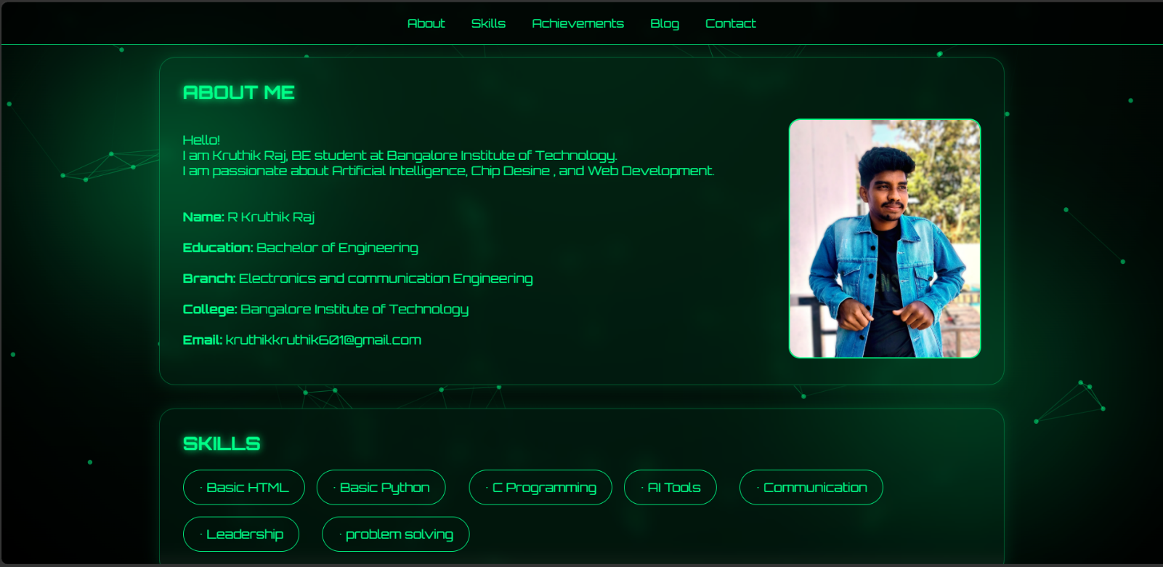

7.3 Achievements and Hobbies section:

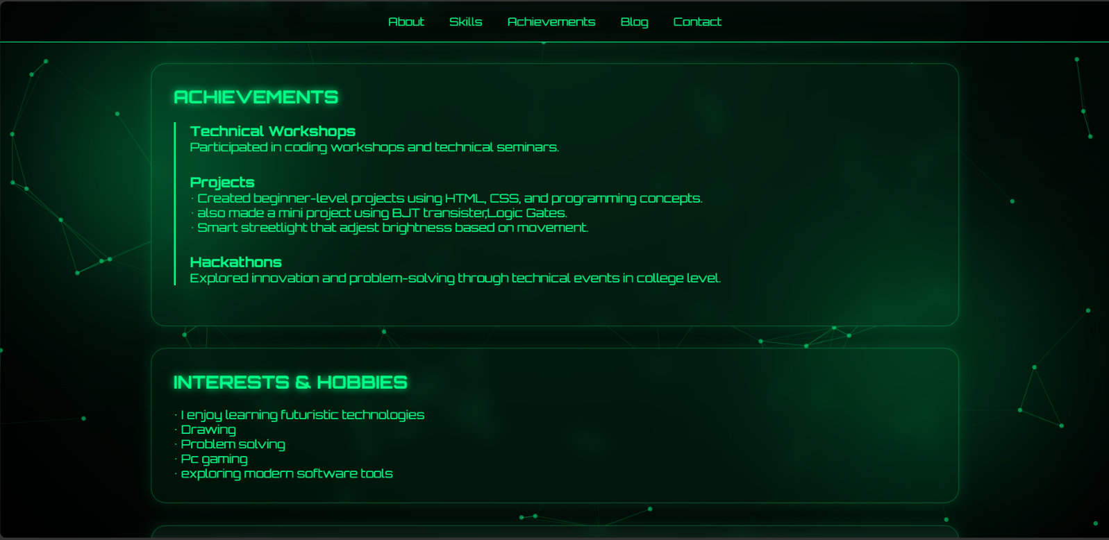

7.4 Interest and contact section:

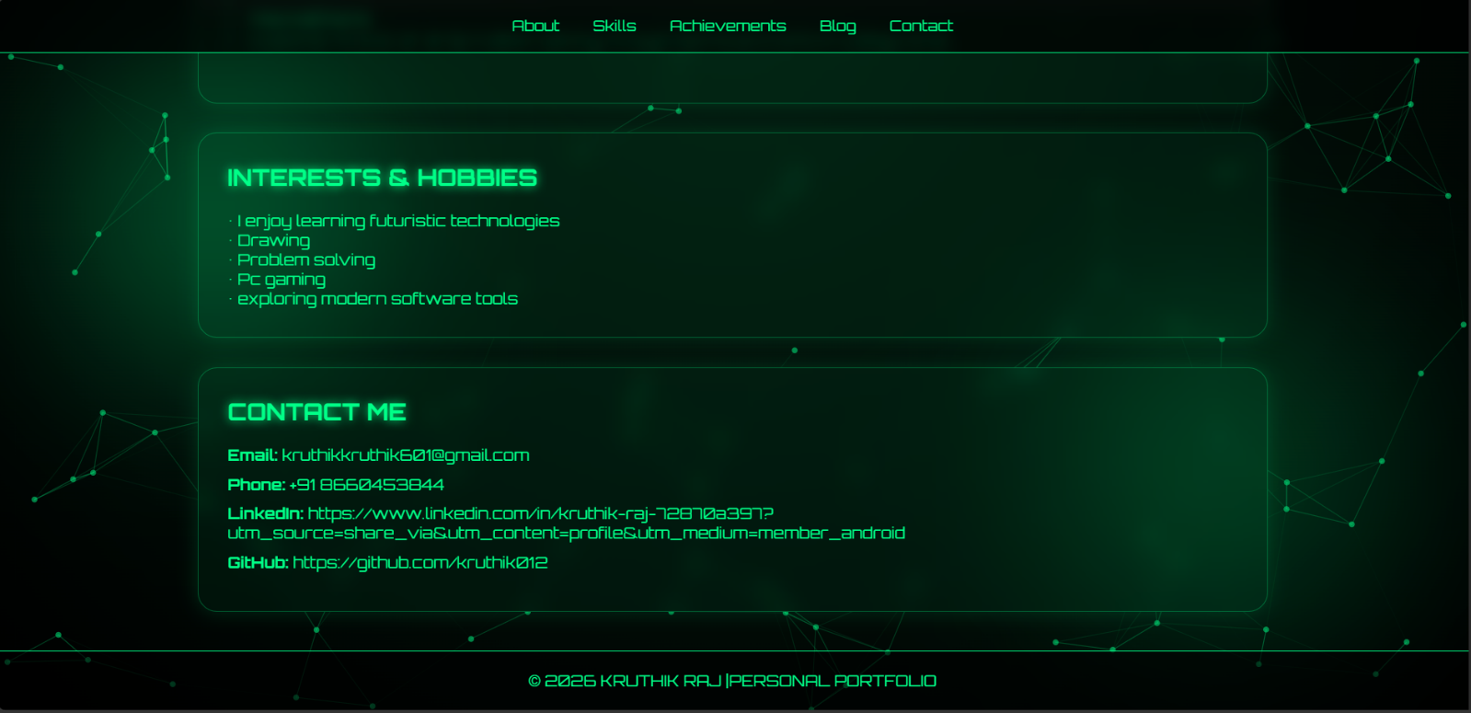

8. System Design
8.1 Website Structure
The website is divided into multiple sections:
Header Section
Navigation Section
About Section
Skills Section
Achievements Section
Interests Section
Contact Section
Footer Section

9. Explanation of Code
9.1 HTML
HTML is used to create the structure of the website.
Examples:
<!DOCTYPE html>
<html lang="en">
<head>
<meta charset="UTF-8">
<meta name="viewport" content="width=device-width, initial-scale=1.0">

<title>Kruthik Raj Portfolio</title>

<link rel="stylesheet" href="style.css">
</head>
<body>
<div id="particles-js"></div>
<nav>
<a href="#about">About</a>
<a href="#skills">Skills</a>
<a href="#contact">Contact</a>
</nav>
<header>
<h1>R KRUTHIK RAJ</h1>
<p>BE Student • AI Enthusiast • Web Developer</p>
</header>
<section id="about">
<h2>About Me</h2>
<p>
I am Kruthik Raj, a BE student at Bangalore Institute of Technology.
Interested in AI, Chip Design, and Web Development.
</p>
</section>
<section id="skills">
<h2>Skills</h2>
<div class="skills">
<span>HTML</span>
<span>Python</span>
<span>C Programming</span>
<span>AI Tools</span>
</div>
</section>
<section id="contact">
<h2>Contact</h2>
<p>Email: kruthikkruthik601@gmail.com</p>
<p>GitHub: github.com/kruthik012</p>
</section>
<script src="https://cdn.jsdelivr.net/particles.js/2.0.0/particles.min.js"></script>
<script src="script.js"></script>
</body>
</html>

9.2 CSS
CSS is used for:
Styling
Layout design
Animations
Glow effects
Responsive design
Example:
body{
margin:0;
font-family:Arial;
background:black;
color:#00ff88;
text-align:center;
}
#particles-js{
position:fixed;
width:100%;
height:100%;
z-index:-1;
background:black;
}
nav{
padding:20px;
}
nav a{
color:#00ff88;
margin:15px;
text-decoration:none;
}
header{
padding:120px 20px;
}
section{
padding:40px 20px;
}
.skills span{
border:1px solid #00ff88;
padding:10px 15px;
margin:10px;
display:inline-block;
}

9.3 JavaScript
JavaScript is used for interactive particle animation.
Example:
particlesJS("particles-js", {
particles: {
number: {
value: 80
},
color: {
value: "#00ff88"
},
line_linked: {
enable: true,
color: "#00ff88"
},
move: {
enable: true,
speed: 2
}
}
});
10. Responsive Design
The website is responsive and works properly on:
Desktop computers
Tablets
Mobile phones
Media queries are used to adjust layouts for smaller screens.
Example:
@media(max-width:768px){
.hero h1{
font-size:45px;
}
}
11. Output Description
The final output is a futuristic cyber-themed portfolio website with:
Animated particle background
Interactive cards
Smooth scrolling navigation
Responsive layout
Personal and professional details
The website provides a modern and visually impressive user experience.

12. Conclusion
The Personal Portfolio Website project successfully demonstrates the use of HTML, CSS, and JavaScript for creating an interactive and responsive web application.
The project improves web development skills while also creating a professional digital identity. The futuristic cyber theme, glowing effects, and particle animations make the website unique and visually appealing.
This project can be further expanded with additional features and advanced technologies in the future.

